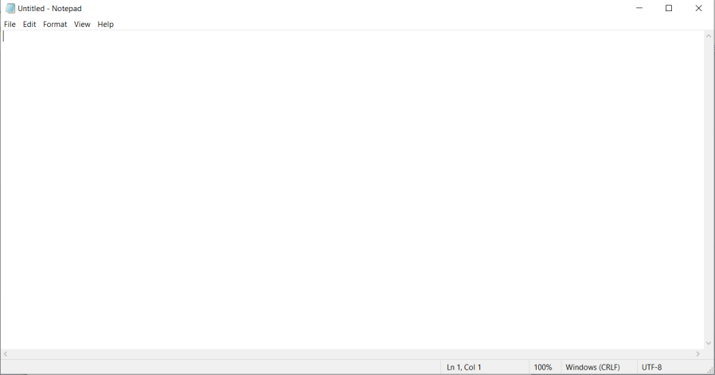
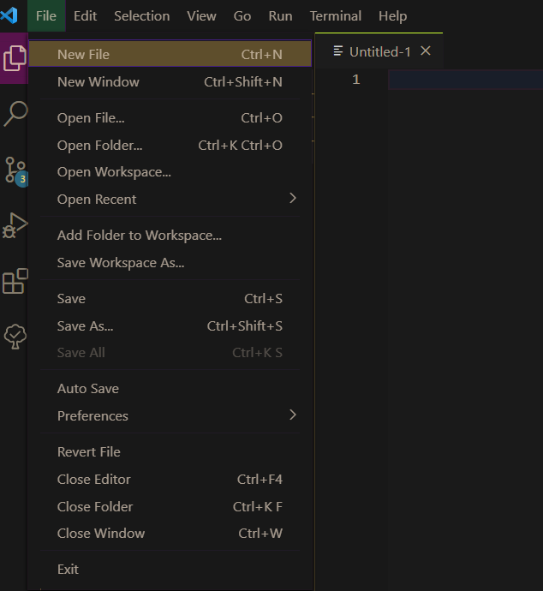
Hello! Hoping you are well
This is going to be a tutorial on how to make a VERY simple webpage. It won’t look very nice but as we go along we can make it look nicer down the line.
Step 1: Open notepad OR go on your code editor and click “new file”, whichever works best for you. I will use notepad for this tutorial.

Step 2: Save the file and name it “index.html” EXACTLY LIKE THAT, no capital letters or anything
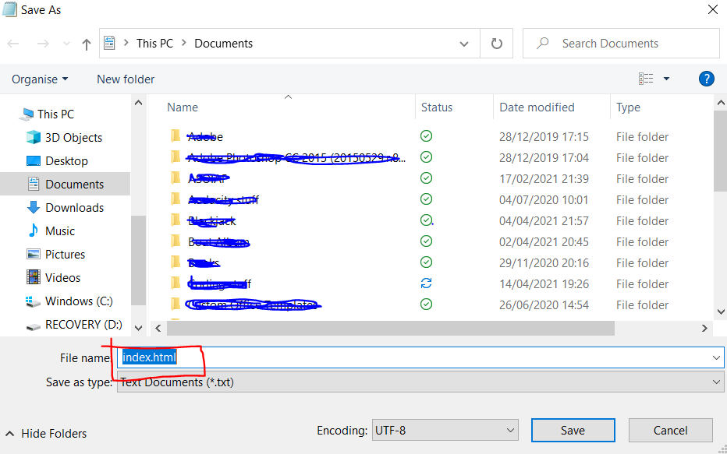
Step 3: Copy the code from the GitHub file named “code to copy and paste” and paste it into your index.html file. Click save. You file should now look like this:
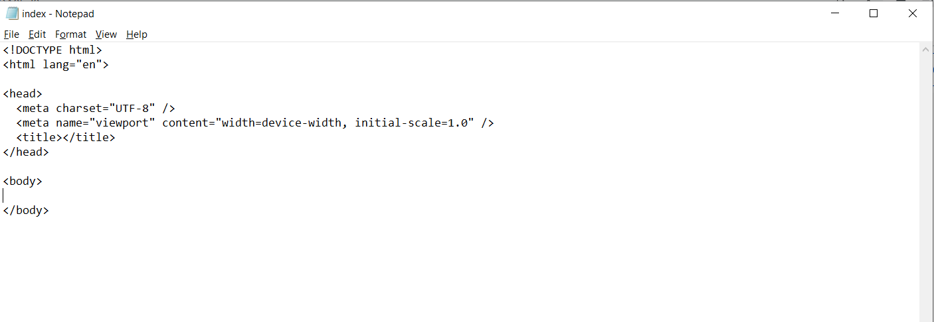
Step 4: Currently the language of the webpage is set to English, if you want to change that to your language, change the “en” on line 2 to the iso code for your language. The list of iso codes for every language can be found at https://www.w3schools.com/tags/ref_language_codes.asp . In the below example, I changed mine from English to French.
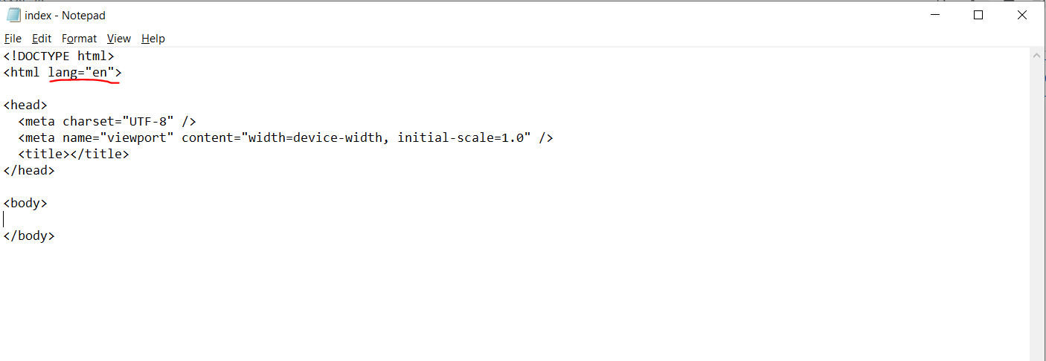
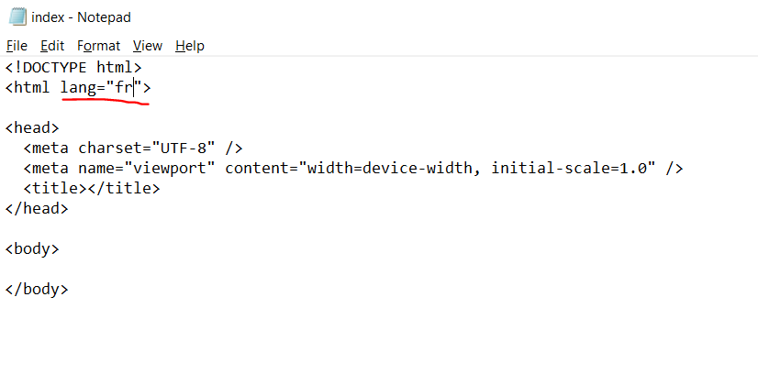
This isn’t needed, it’s just a good habit to pick up!
Step 5: Locate where your index.html file is located on your computer, then double click it. This should open the webpage in your browser, my browser is Google Chrome. The webpage should be completely blank.
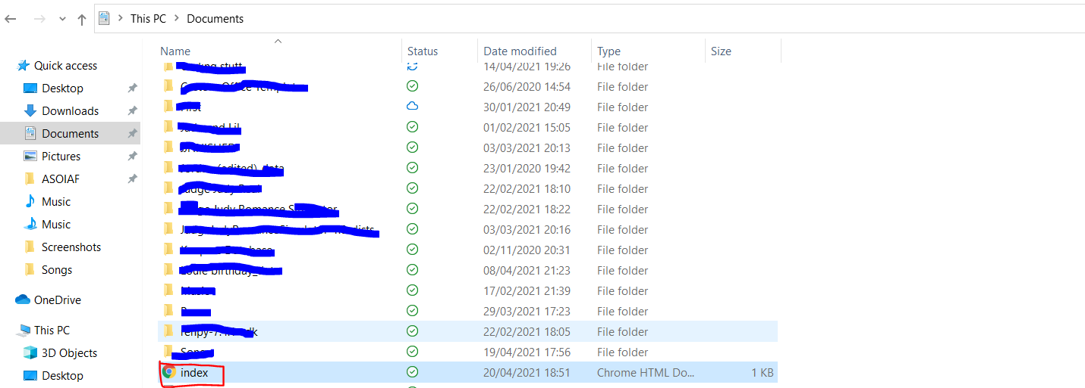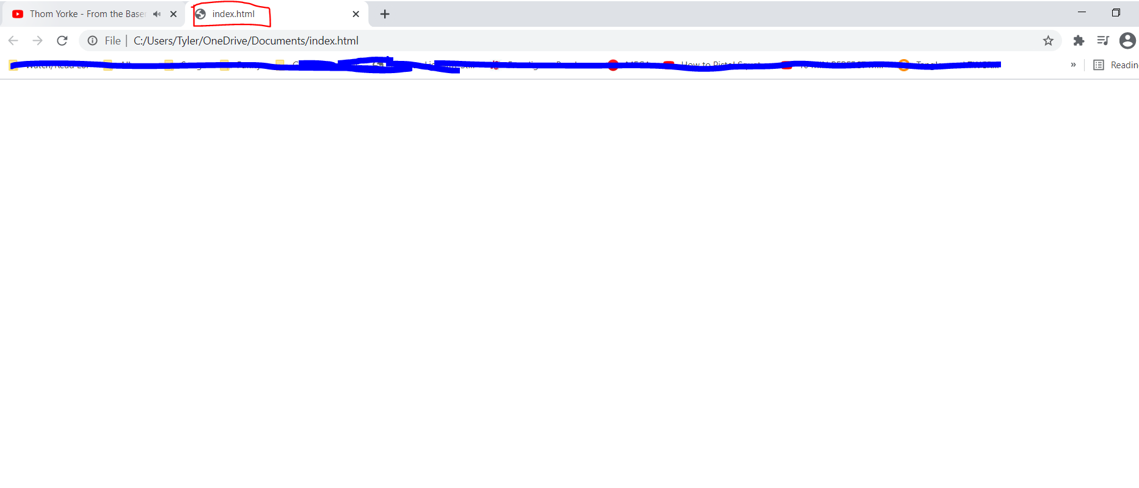You now have a webpage! Before we start putting things in it, I’ll briefly explain each bit of the code.
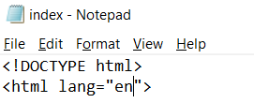
The “<!DOCTYPE html>” let’s your computer know that this is a HTML file, which are the files that websites are made from. As mentioned before, the <html lang=””> bit tells your browser what language your webpage is in, mine is in English.
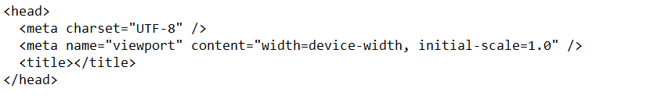The code between the <head> and </head> tags just tells your browser things about the webpage, this isn’t where you add text or anything. We will change the “<title></title>” soon, but please don’t touch the <meta charset=”UTF-8” /> and <meta name =…/> tags, you will NEVER need to change them.
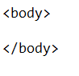
The code that goes between the <body> and </body> tags are what we will change, this is where we can add text/images.
NOTE: for some of the below steps, the results won’t appear until you refresh your webpage. Every time you add/remove something, click “save” and then refresh your page and it should appear.
Step 6: Let’s add a title. If you look at the tab in your browser, it will just say “index.html”, we want to change that. In between the <title> and </title>, type in what you want your website to be called. I’m going to call mine “Tyler’s website!” As you can see, the tab has now changed to say what I’ve put in between <title> and </title>
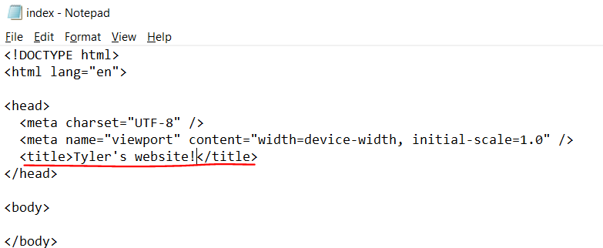

Step 7: Let’s add a title and some text to your page! Please type (or copy and paste):
<h1></h1>
<p></p>
Into your index.html file in between the <body> and </body> tags. It should look like this:
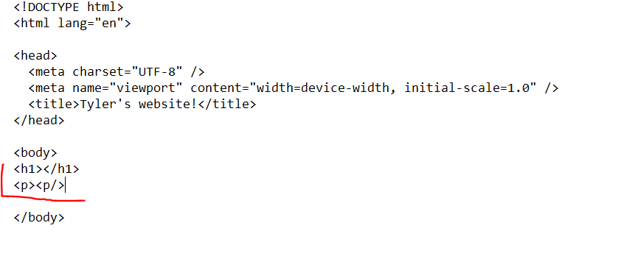The h1 means “Heading one” and the p means “paragraph”. Let’s add a heading! Please type anything you want between the <h1> and </h1> tags. I’m going to type “This is a heading, yay!”. As you can see, the heading has now appeared on my webpage.
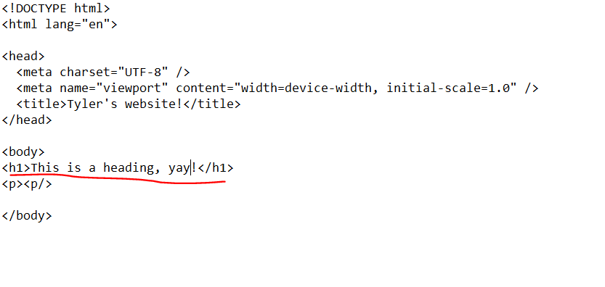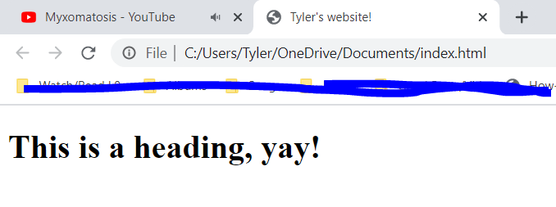

Step 8: OK final step, let’s add some text. Like you just did for the <h1> tags, in between the <p> and </p> tags, type in anything you want and it will appear as text. I’m going to type “My favourite animals are cats and frogs” and again, it appears in the webpage.
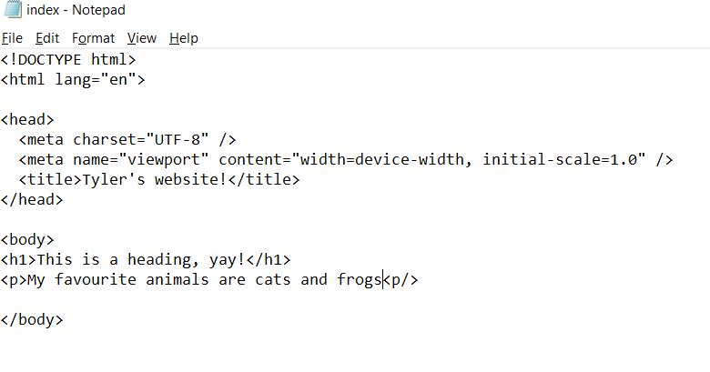
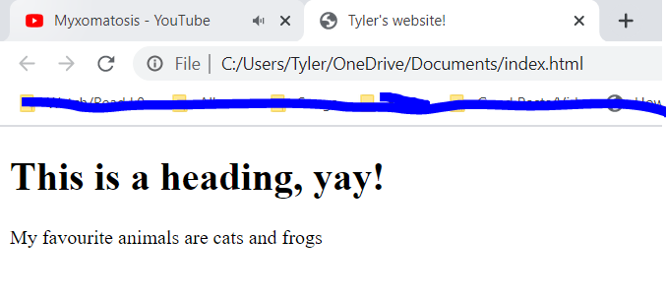
Well done, you’ve made a webpage!
Obviously it looks bad currently, but if you manage to do this OK, we can add things later to make it look nice and like a proper webpage.
I hope you found this useful!

